**Experiment 10**

**Aim:** Nexus integration with Jenkins.

**Procedure:**

**Step 1:** Make the changes to the pom file of the project and the maven settings

**Step 2:** Install the following plugins:

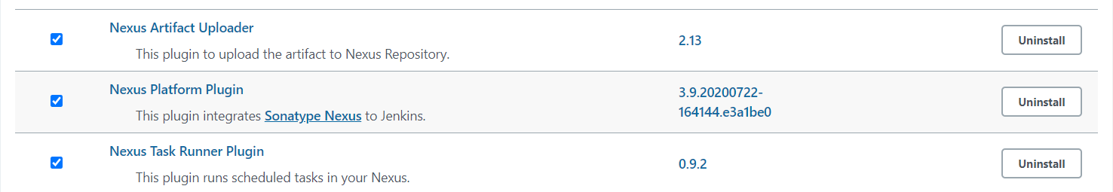

**Step 3:** Configure the plugin to integrate with Jenkins.

The changes to be done in the global tool configuration

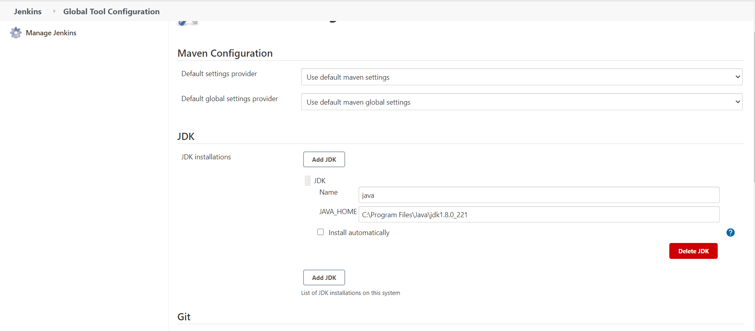

The changes to be done in configure system:

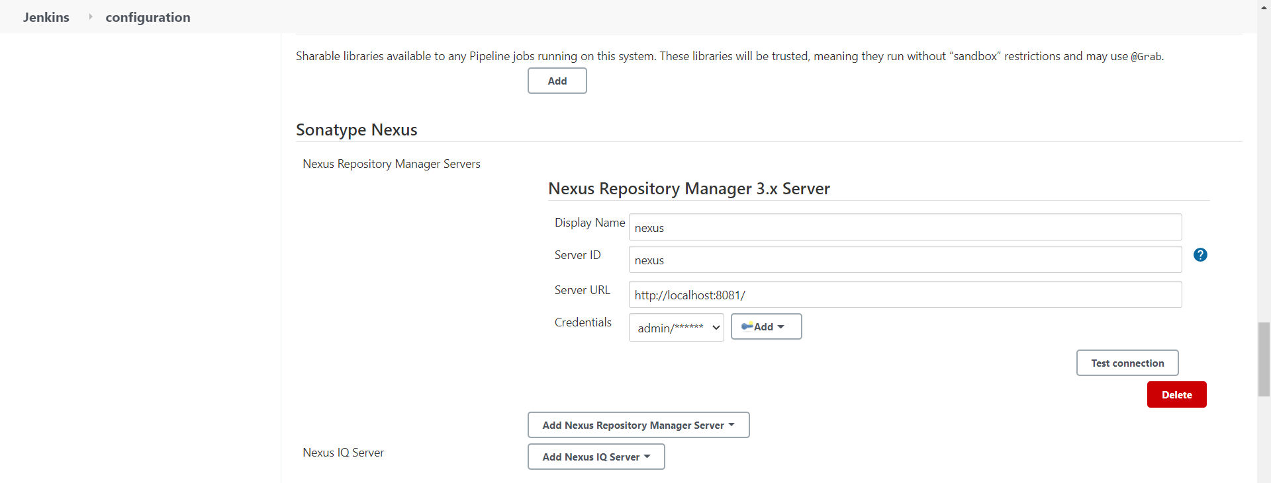

**Step 4:** Configure a Jenkins job to deploy the project on the nexus server

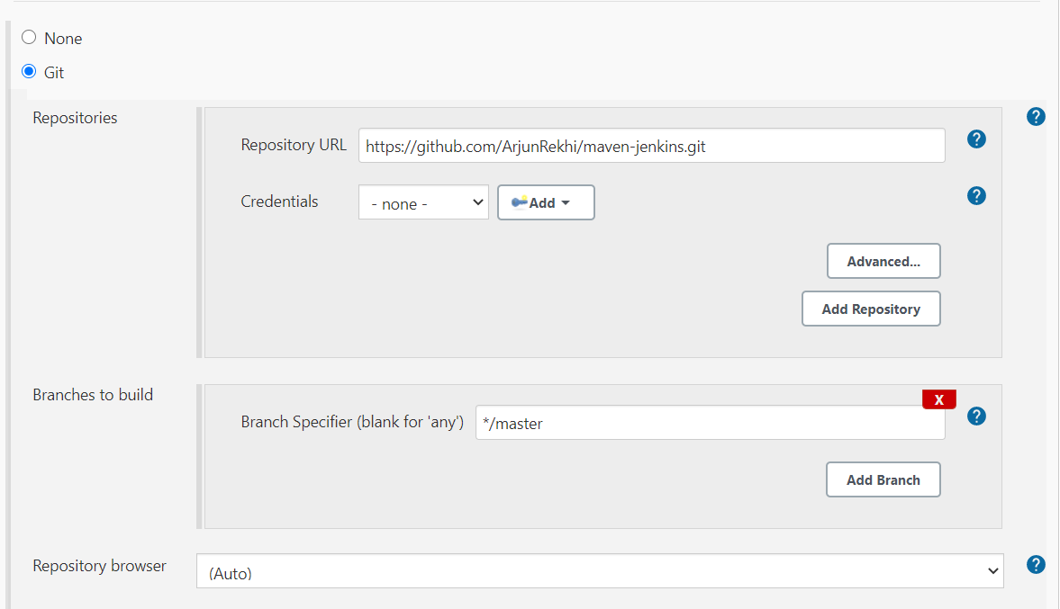

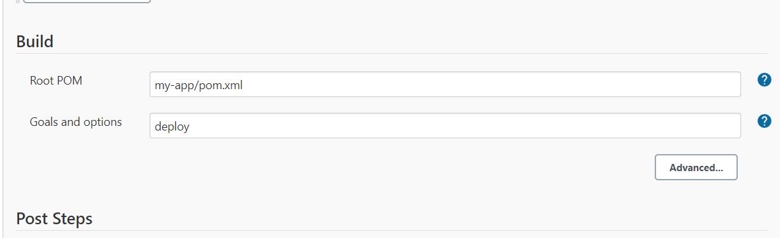

**Step 5:** Click on build now to start the job.

The output as seen in console output:

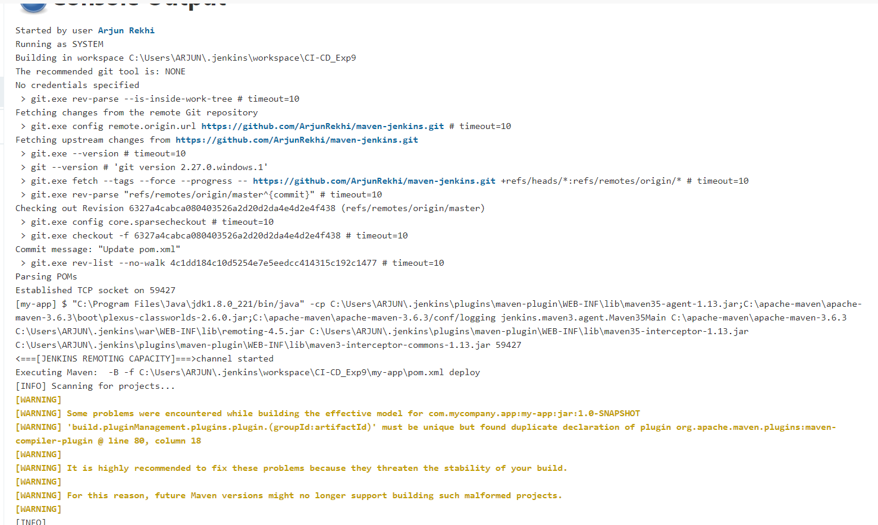

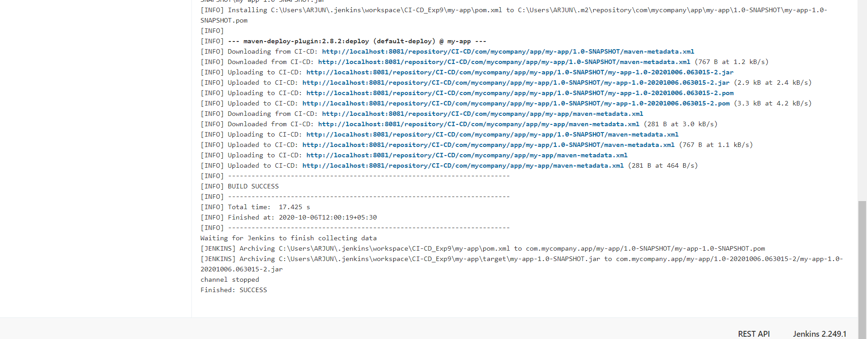

At the end of this job the project has been uploaded on the nexus server. It can be viewed on the nexus dashboard as well.

**Step 6:** Go to the dashboard and check if the project has been uploaded/

Output as seen on the dashboard:

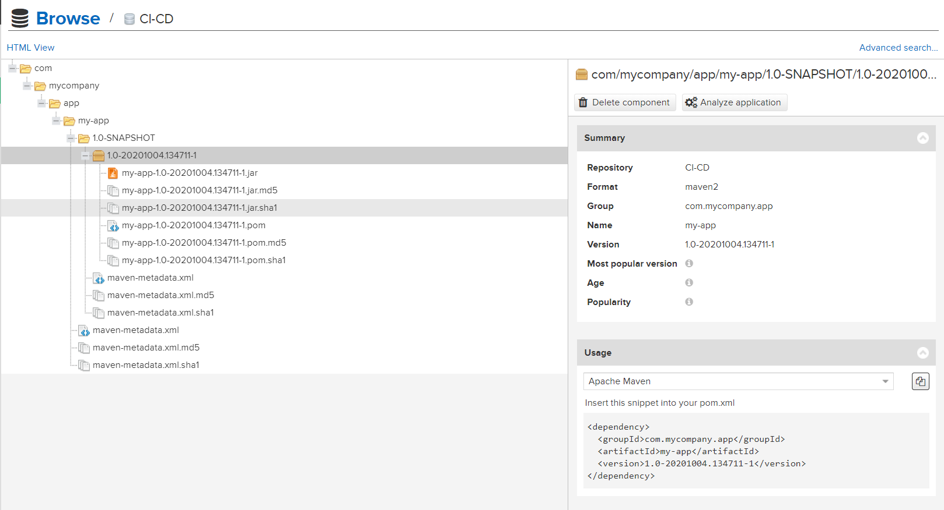

Submitted by:

Arjun Rekhi

500068109

R171218028